Designing the Future for Online and Mobile Tools
2018 CEO Strategic Developers Boot Camp
CU*Answers | 10/1/18 | Segment C

Contents
Designing the Future for Online and Mobile Tools 4
What is Online 19? 4
Section 1 – Where are we today? 6
Section 1 – Discussion 8
Remembering cuanswers.com 9
Remembering Online Banking 12
How the relationship of Online Banking and Website works today 18
Section 2 – A Crossroads 20
Section 2 – Discussion 22
Section 3 – What if? 24
Section 3 – Discussion 26
Section 4 – Can we pull it off? 28
Section 4 – Discussion 30
Limiting the Activities Available 30
Fueling the Sales Engine 32
What sales opportunities can we offer? Brainstorm a list of sales scenarios below: 33
The Mobile Situation 36
Regulatory Considerations 36
Pulling it Off 37
Appendix - Concepts & Mockups 40
Concept – Index Page 42
Concept – Action/Sales Engine 43
Concept – Tabbed content for Logged In Action vs Logged Out Marketing content 44
Concept – Related Promos in Transaction History 45
Concept - Mint.com – in transaction listing promotions 46
Concept – Screen Real Estate 47
Concept – Not Logged In – Transfer Money 48
Concept – Logged In – Transfer Money 49
Concept – Drawer Slide Out Online Banking (closed) 50
Concept – Drawer Slide Out Online Banking (open) 51
Concept – Partial Authentication – First Visit 52
Concept – Partial Authentication – Welcome back 53
Concept – Partial Authentication – First Visit 54
Concept – Partial Authentication – Returning Visit 55
Concept – Partial Authentication – Log In 56
Concept – Partial Login – Dark Panels 57
Appendix - Optics Events – It’s Me 247 Desktop 58
Appendix - Optics Events – It’s Me 247 Mobile 61
Appendix - Current It’s Me 247 Navigation 63
Appendix - Additional Reading 66

Designing the Future for Online and Mobile Tools

What is Online 19?
Online 19 is the codename for our discussion and project about designing the future for online and mobile self-service options. That includes transactional online banking tasks as well as the marketing component of your credit union website. Specifically, what if we could merge the two into a single website, where your membership authenticated directly on your website and never left?
This workbook is a guide to help us design what this might be, to discuss what the tradeoffs might be and how they affect your online presence. With new insight into your member’s online activities, how would your credit union leverage this knowledge?
This discussion and brainstorming about Online ‘19 is the project.
Certainly, aspects of this dialogue will work their way into future iterations of our collective online products. But whether a distinct product derived from these conversation remains to be seen.

Section 1 – Where are we today?
Reviewing where we are today with online banking for desktop and tablet approaches. How do we see the future of CU websites from both a CU and CUSO perspective?

Section 1 – Discussion
Review where we are today with online banking for desktop and tablet approaches. How do we see the future of CU websites from both a CU and CUSO perspective?
- Think back to what Online Banking was 10 years ago, what made it successful?
- What makes Online Banking successful today?
- What will make Online Banking successful in the future? Tomorrow, next year, 5 years?
- Think back to your website 10 years ago, what made it successful then?
- What makes your website successful today?
- What will make your website successful in the future? Tomorrow, next year, in 5 years?
Remembering cuanswers.com
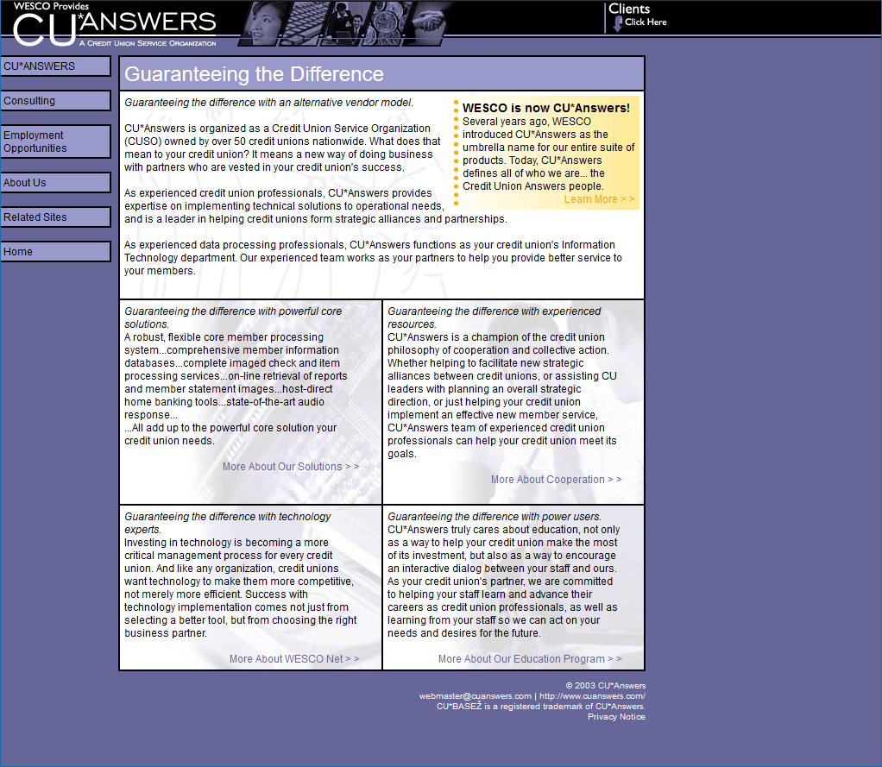
October 2003
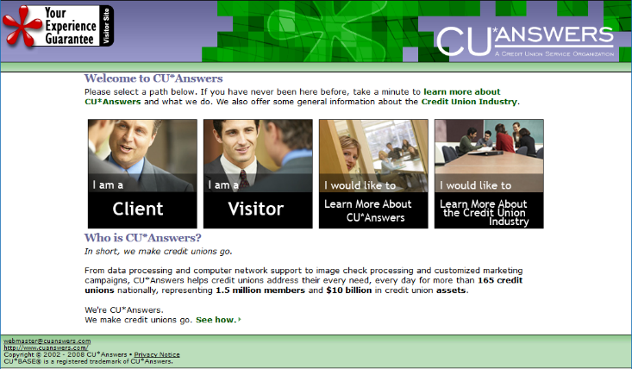
May 2008
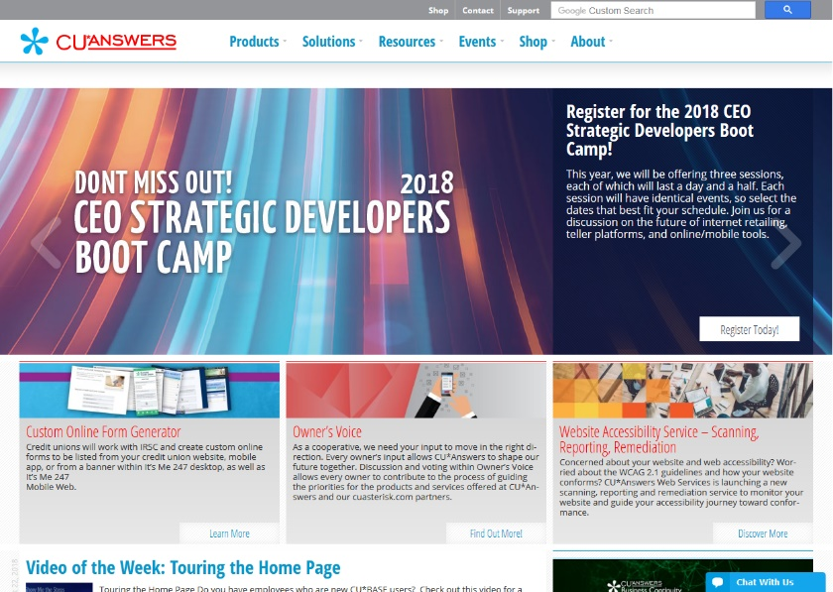
October 2018
Figure 3 cuanswers.com in October 2018

Remembering Online Banking
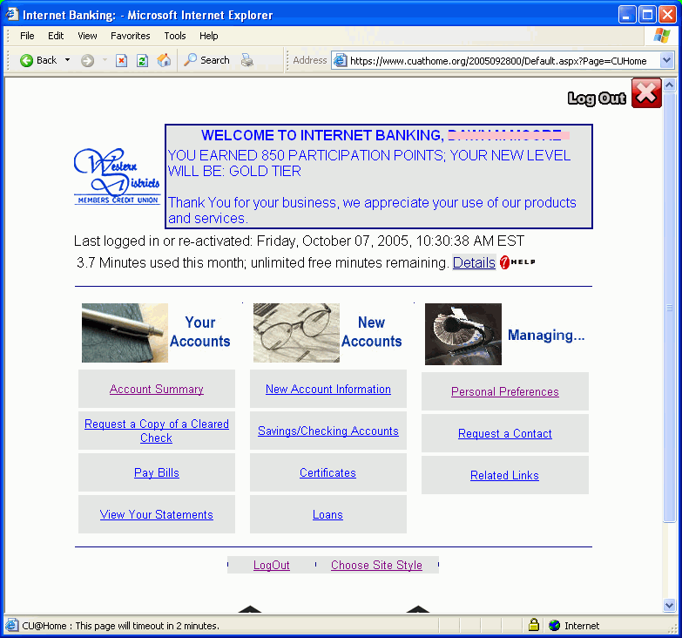
2005
2005
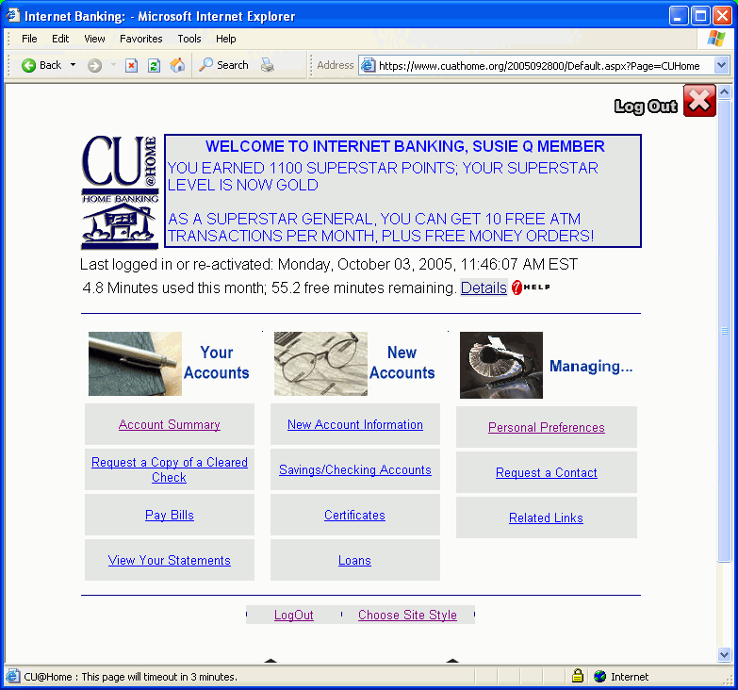
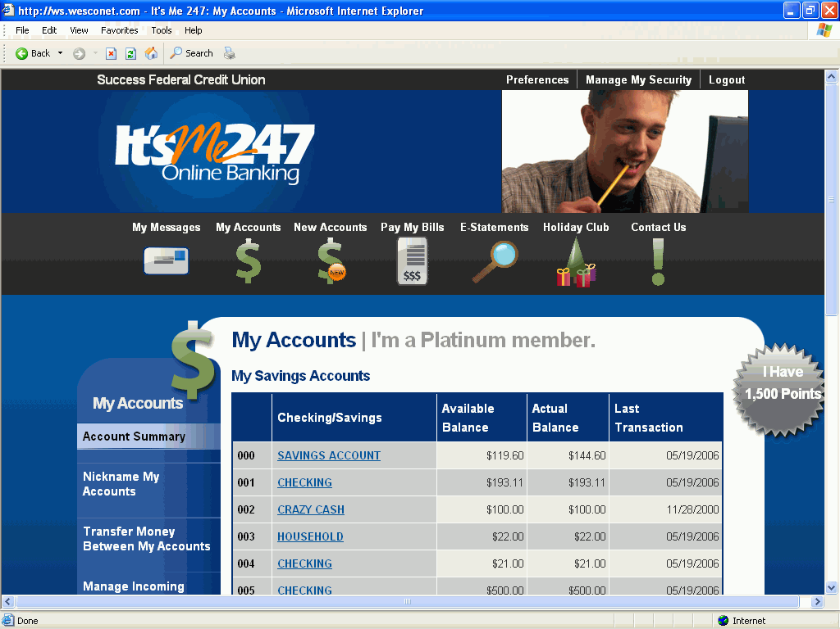
2008
2008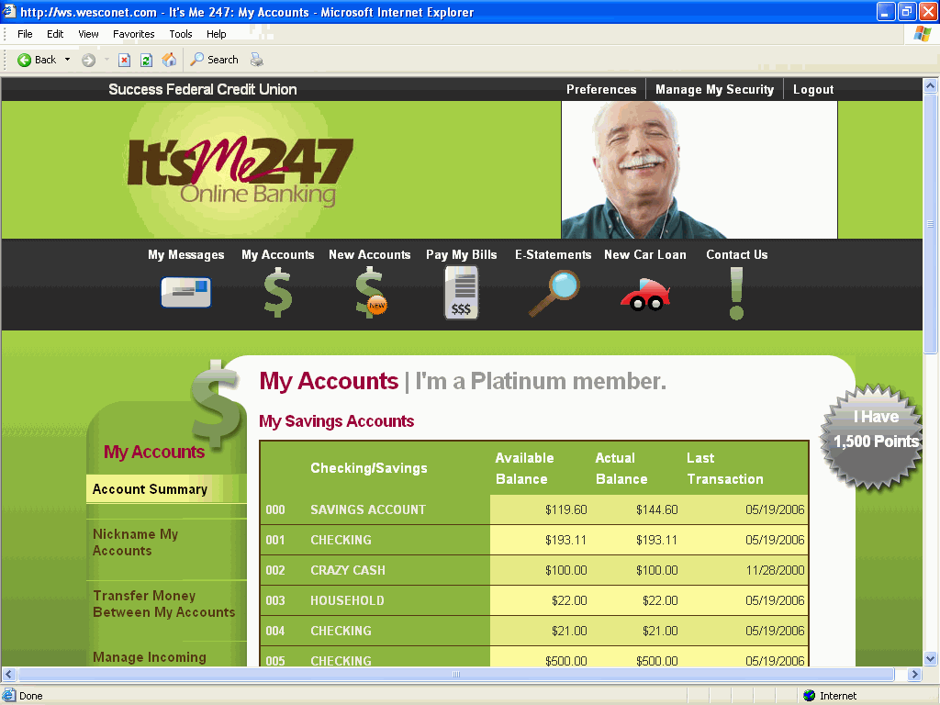
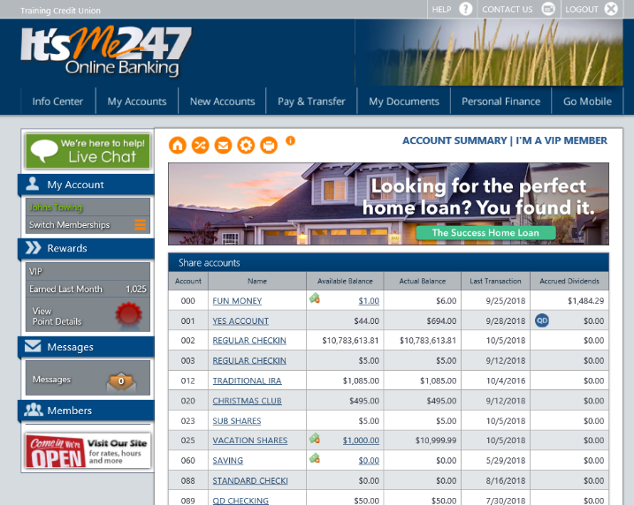
2018
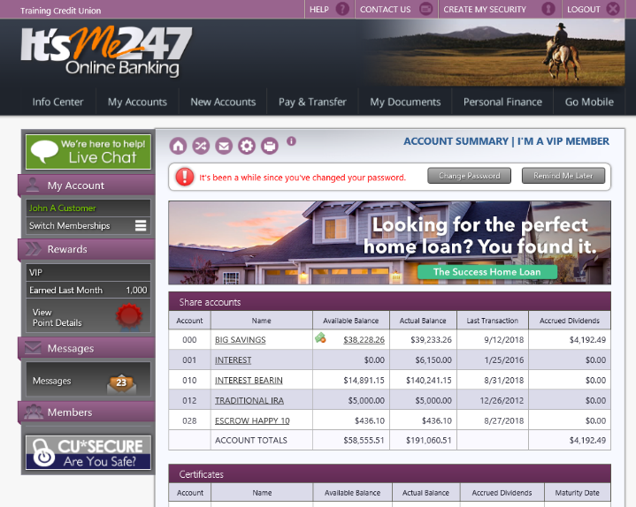
2018

How the relationship of Online Banking and Website works today
Let’s review how members access online banking from your website today. This seems like a simple concept, but as you can see from this documentation from Web Services there are many options and nuances to how it works.
- Traditional
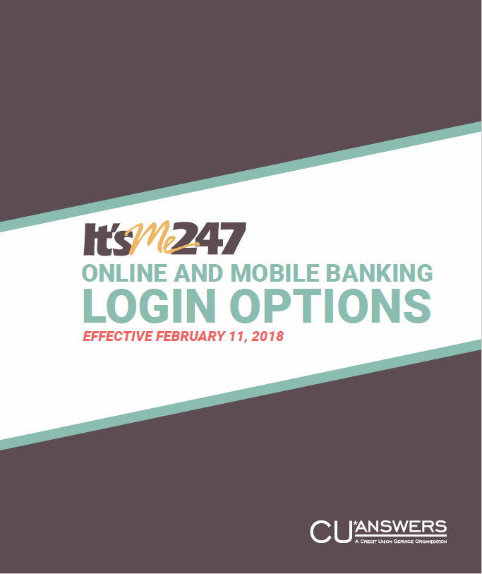
  - Website → OBC → It’s Me 247
  - Represented by one of the following:
    - Login Button
    - Direct Login Widget
    - Targeted Direct Login Widget
  - OBC fulfills certain regulatory requirements for credit unions
    - Financial, security and identity theft education
    - Maintenance and system problem messages
    - Mobile detection
- Proposed OBC Bypass
  - Website → It’s Me 247 (bypassing the OBC)
  - Represented by one of the following:
    - Direct Login Widget
    - Targeted Direct Login Widget
  - Credit union is responsible for OBC functions
  - Has proven to be a technical challenge due to browser security differences
- Mobile detection and responsive web design
  - OBC redirects mobile browsers to It’s Me 247 mobile web
  - Responsive websites handle redirection at the code level
- Describe challenges you see in how members access online banking from your website.

Web Services training guide for new employees explaining It’s Me 247 login options
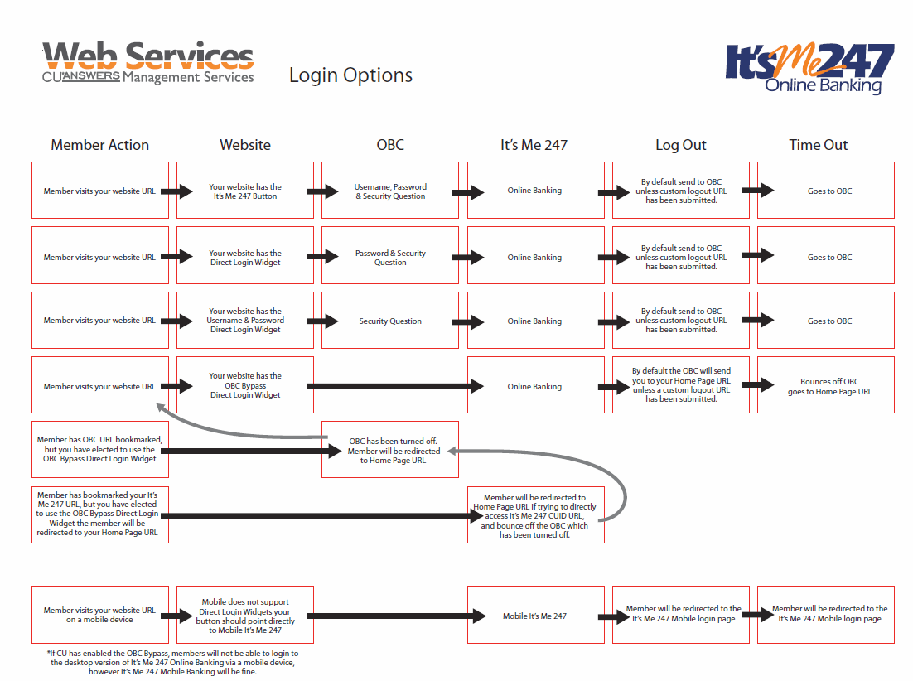

Section 2 – A Crossroads
The next generation of the current approach vs. going rogue for a new approach. Can we do both? Must we do both? Who will pioneer each set?

Section 2 – Discussion
A crossroads: The next generation of the current approach versus going rogue for a new approach. Can we do both? Must we do both? Who will pioneer each set?
- Brainstorm on continuing with the current approach (separate transactional online banking and marketing websites)
Pros of this approach | Cons of this approach

- Brainstorm on a new authenticated member approach (combine transactional online banking and marketing websites)
Pros of this approach | Cons of this approach

Section 3 – What if?
Adopting a member-authenticated CU website. How would CUs see the channel if they knew 80-85% of the visitors, and channeled differently the people they did not know?

Section 3 – Discussion
What if we adopted a member-authenticated CU website that included the transactional activities of online banking all baked together? What if the focus of your online presence was knowing your member and focusing on serving your existing member?
Vocabulary
What does personalization mean?
What does contextual engagement mean?
What is the difference between descriptive analytics and predictive analytics?
- How would you see your website if you knew 80-85% of the visitors, and channeled differently the people you did not know?
- What would you have to do differently if you knew who was browsing your website right now?
- How would you capitalize on this knowledge?
- What tradeoffs would you be willing to make for this data? Functionality? Control? Design? Privacy?
- How would this affect your privacy policy?

Section 4 – Can we pull it off?
A new approach to dual navigation and an orchestrated dance between the values of a website and the actions of a banking toolset.

Section 4 – Discussion
Can we pull it off? A new approach to dual navigation and an orchestrated dance between the values of a website and the actions of a banking toolset.
Let’s brainstorm on what the tradeoffs might be. How do we get to a Phase 1 prototype?

Limiting the Activities Available
- Would you be willing to limit the pages that your site contained? Why or why not?
It’s Me 247 Desktop Optics
Let’s review the Optics (see “Appendix – Optics Events – It’s Me 247 Desktop”)
Note that not all features are in Optics, notably message center (see “Appendix – Current It’s Me 247 Navigation” for reference)
Spoiler: 60% of all activity is viewing transaction details
Add the next 4 actions and we’re already over 90% of activities
Is that good enough? What would be?

- What features of It’s Me 247 Online Banking could be left behind? (See the “Appendix – Current It’s Me 247 Navigation” for reference.)
- What actions are required for compliance reasons, even if not used?
- What actions are required for member experience, even if rarely used? Remember that some actions spawn a whole subset of other actions (e.g., bill pay needs enrollment vs the actual use to pay bills, ability to manage payees, manage bills, manage schedules, etc.)
- How should logged in/logged out/non-members be handled?
  - What would you show on an action panel when a member isn’t logged in?
  - What would you show on an action panel when a member hasn’t enabled a feature?
- Is limiting features in online banking the opportunity to add gradual acceptable use agreements?
- What if you required all access to your entire website to be authenticated (i.e., members must sign in before seeing anything)? What would you do with non-members?
- Would you redirect non-members to your MAP/MOP site? Why or why not?
- Would you be concerned about how this affects your search engine rankings (SEO)? Does it matter? Why or why not?

- Besides online banking pages, what marketing pages are needed that do not have transactional activity on them?
Some Marketing Page Suggestions
- About us
- Contact Us
- Partners
- Privacy Policy
- Disclosures
- Other Important Numbers (could be listed under contact/about)
- Locators
- Social media

Fueling the Sales Engine
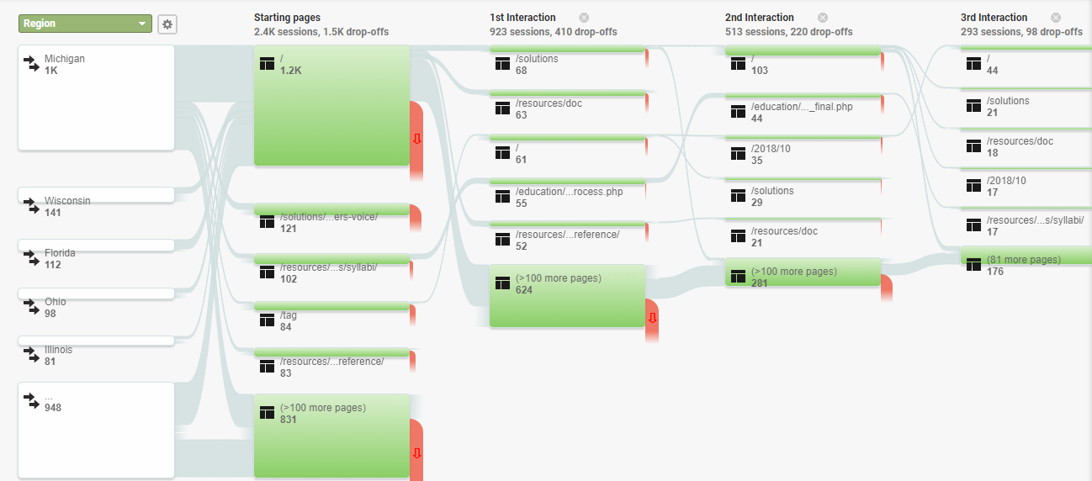
- If you knew every online action of your authenticated member on your website, what would you do with the data?
- Where would you view this tracking data showing what the member is doing on your website (specifically, by the member)?
Figure 1 Google Analytics Visitor Behavior
- Where is this data stored and for how long? Would you consider this to be private data?
  - CU*Publisher? Request Center? CU*BASE?
  - Analytics Booth doesn’t have private data
  - As part of your website?
  - Something else? Is this Optics 2.0?
- If you have this data, what do you do with it?
- How do you determine a member is interested in ___________________?

What sales opportunities can we offer? Brainstorm a list of sales scenarios below:
Are these suggestions that make the credit union money? Save the member fees? Improve the perception of their service?
If the member… | Suggest they…
Has over $_________ in savings | Buy a certificate
Has a loan about to be paid off | Pre-approved for ______________
Doesn’t have a credit card | Apply for one
Doesn’t have eStatements | Enroll for eStatements
Doesn’t have bill pay | Enroll for bill pay
Has a bill due | Pay bill
Is over ___ years old and __________________ | ???
Is/is not __________________ | Pre-approved for  - Auto loan  - Mortgage  - HELOC  - Credit Card
Has _________________ | Skip a payment
- Describe how you would manage that member X should be shown offer Y? Where would this system operate?
- Is this tagging of member automatic based on standing rules you create? What are those rules?
- Would you buy canned cooperative campaigns that includes a bucket and targeted campaign? What would you pay?
- Is “sales” the right word for this process? Why or why not?
- How does this process relate to Next Suggested Product in CU*BASE?
- If you knew a member kept viewing your auto loan rates, what would you want the website to do?
Predictive Analytics

What if Asterisk Intelligence could tell you the average age for a member to get their first car loan? Would you target these members with a special marketing campaign and have them pre-approved?

The Mobile Situation
- Would you be willing to not offer mobile web online banking at all – only an app? Why or why not?
It’s Me 247 Mobile Optics
Let’s review the Optics (see “Appendix – Optics Events – It’s Me 247 Mobile”)
Spoiler: 85% of members simply view transaction details.
What if you had a micro app that just showed balances and transactions?
The next 8% are doing transfers.
Just these 2 actions cover 93% of all mobile web activity.
- How about showing a mobile splash page that directs mobile members to download apps specific to their needs? Think Micro Apps or your app store.
- Would you rather that mobile browser detections redirect mobile members directly to It’s Me 247 Mobile Web Banking? Why or why not?

Regulatory Considerations
- How does a member get to PIB to manage layered security? What if all access required authentication first?
- How would you handle other regulatory and cooperative requirements like security education and training? Would you manage these yourself? Where would you find content?
- Describe how you would handle service-related issues and alerts, both planned and unplanned? How would these be communicated to your members?

Pulling it Off
- Given the sky is the limit, what does this type of site look like? Remember, you may have to trade off limited customizability as marketing content and transactional actions have to fit together. Draw a sketch:
- What if all marketing content had to fit in a template – think Mad Libs-like fill-in-the blanks. Is this a deal breaker? Why or why not?
- What if you were limited to only market 3 credit card types (for example)? Would this be a deal breaker?
Limited Customization

Think about Self Service Channel Custom Branding Options, would this base set of customizations be enough? Why or why not?
- Logo
- Primary color
- Secondary color
- Monthly banner ads
- Monthly marketing content
- How important is a content management system for your team to be able to make their own web updates? Why?
  - Are you concerned about breaking the rendering (how it looks in a browser) of the website?
  - What about browser testing?
  - How important is WCAG conformance? Today? In the future?
- Is requiring web updates to be performed by Web Services Professional Services so that online banking actions aren’t broken a deal breaker? Why or why not?
- In your mind does this type of code and marketing content integration require professional coders and developers versus the ease of use for marketing individuals to make content changes?
- How much are you spending on web work annually? How much is marketing content updates?
Web Services Professional Services

In 2017, CU*Answers Web Services maintained credit unions spent just under $400 per year on web updates. Ten credit unions spent over $1,000 for the year on web updates.
[2017 daily production = $43,473.99 / 114 CUs = $381.35]
- How often is your marketing content actually changing? Is it frequent enough? Should it be more or less?
- Does your credit union participate in the cooperative campaigns? Why or why not?
- Are you using Request Center to be an internet retailer? Why or why not? What forms could be built for Request Center to raise your internet retailing game? See the forms gallery at https://irsc.cuanswers.com/pages/portfolio/forms-gallery/

Appendix - Concepts & Mockups
The following are some concepts and mockups created by the CU*Answers Teams.
Remember the tip-of-the-iceberg t-shirt from the 2017 Leadership Conference? These concepts are superficial and there are multitudes of technical details to be worked out on the delivery.

Concept – Index Page
Showing a traditional credit union index page.
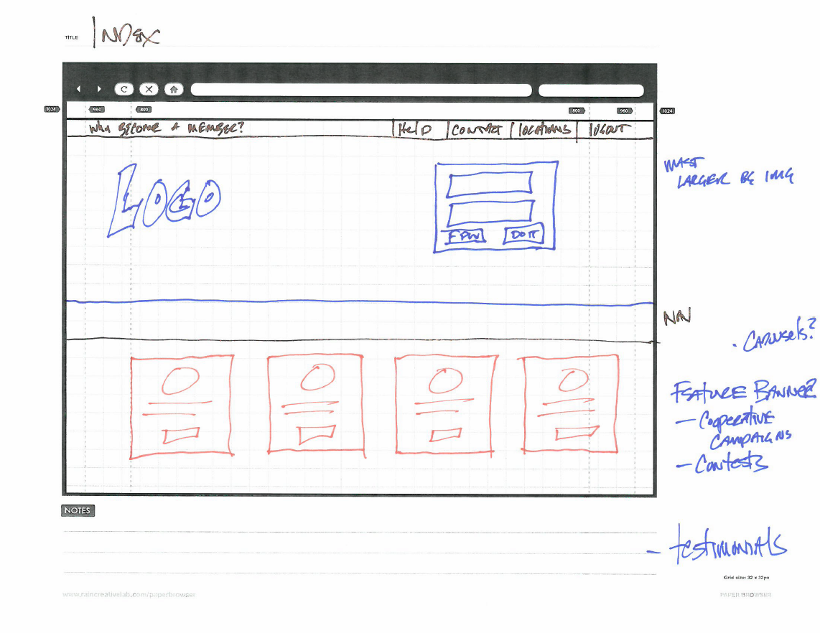

Concept – Action/Sales Engine
Showing a credit union index page with side-by-side welcome back and account quick reference and sales engine concept.
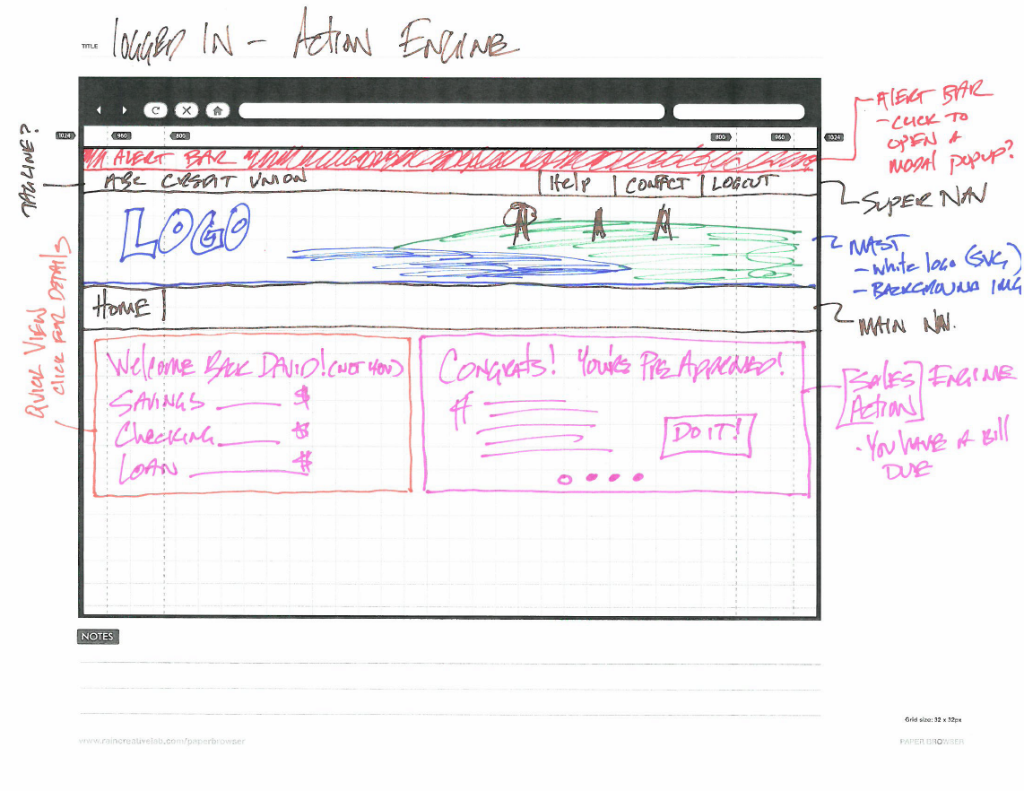

Concept – Tabbed content for Logged In Action vs Logged Out Marketing content
Showing a tabbed interface for logged in action versus logged out marketing content. This allows the member to view both.

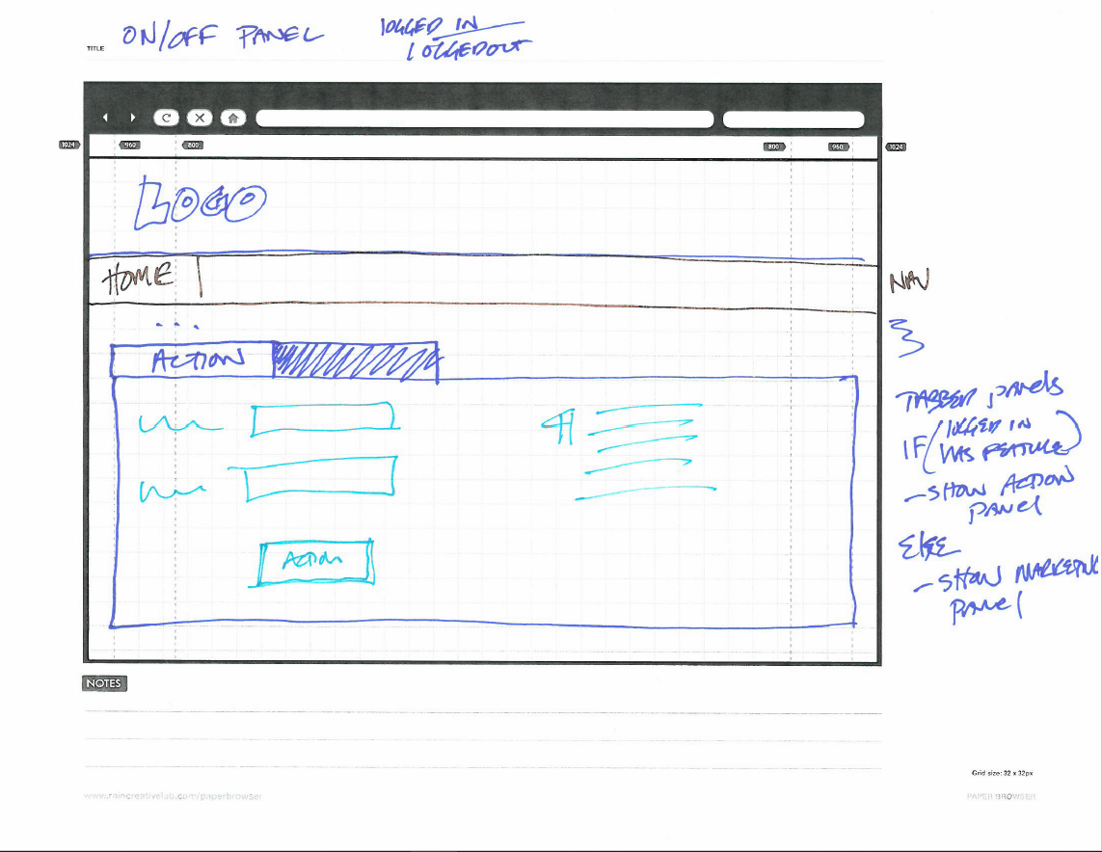

Concept – Related Promos in Transaction History
Showing related promotions inline in the transaction history.

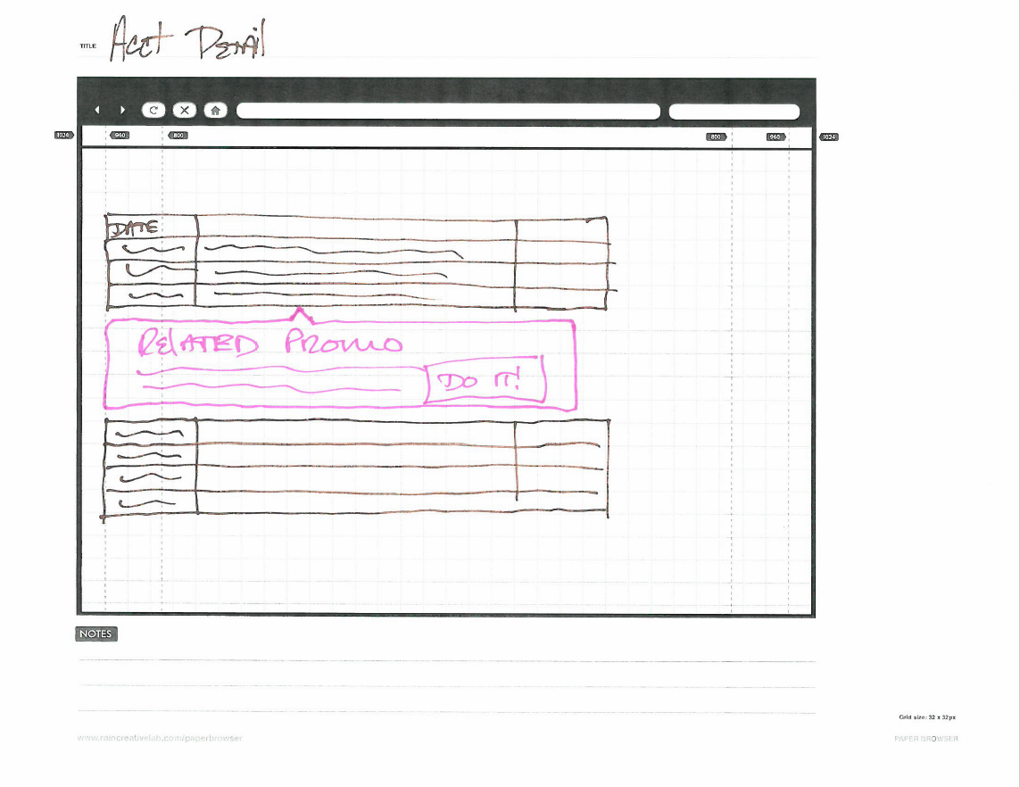

Concept - Mint.com – in transaction listing promotions
Showing mint.com’s version of transaction history promotions.
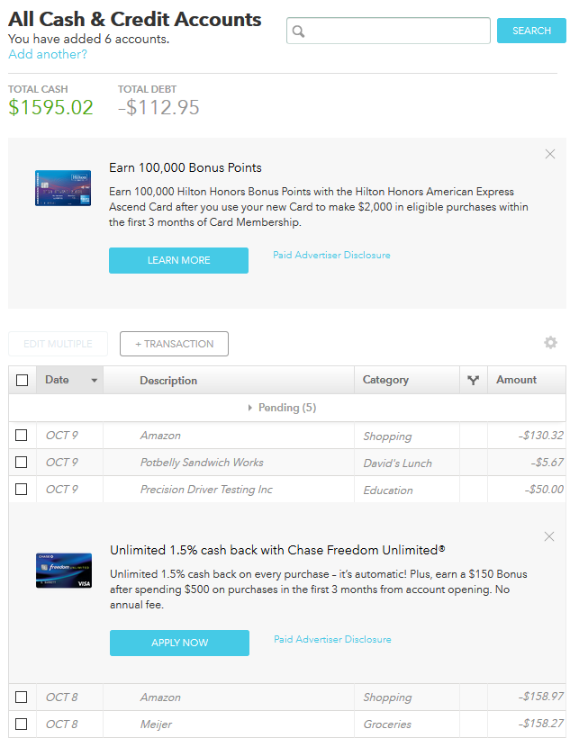

Concept – Screen Real Estate
Showing a break down of screen real estate for a side-by-side quick account access and sales engine content blocks.
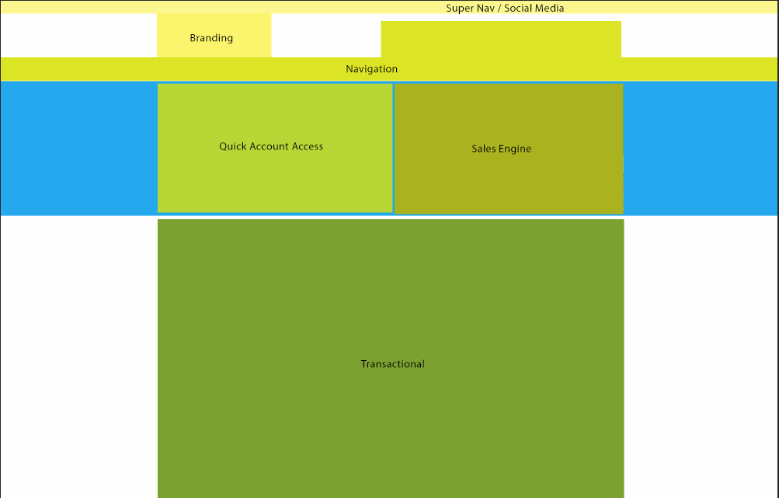

Concept – Not Logged In – Transfer Money
Showing side-by-side quick account reference, member has not logged in, therefore marketing content is shown in the body.
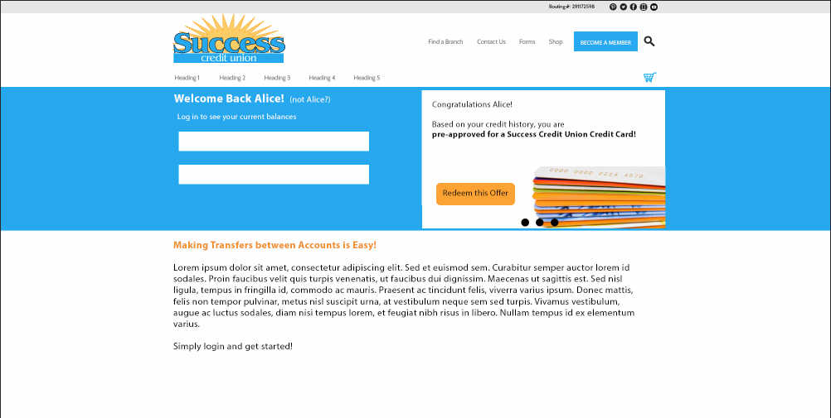

Concept – Logged In – Transfer Money
Member has logged in. Main body content is now transactional online banking and quick account reference is shown.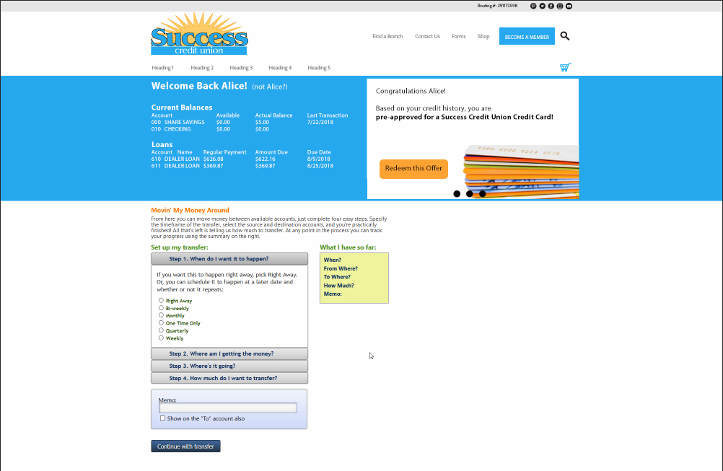

Concept – Drawer Slide Out Online Banking (closed)
Showing a slide out drawer concept for online banking. The drawer is currently closed.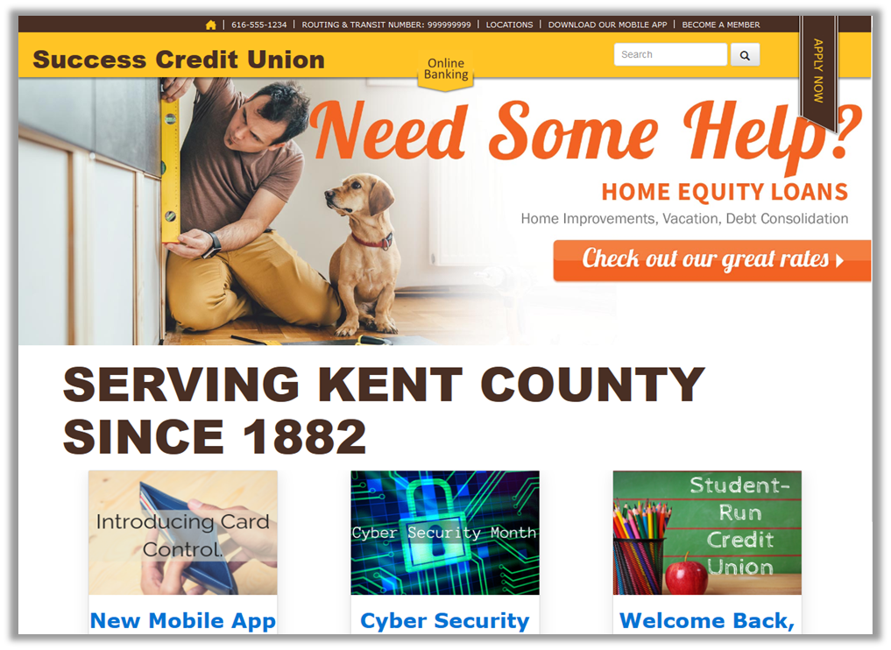…

Concept – Drawer Slide Out Online Banking (open)
Member opens the drawer to view online banking. Drawer is context aware of which page of the website the member is on.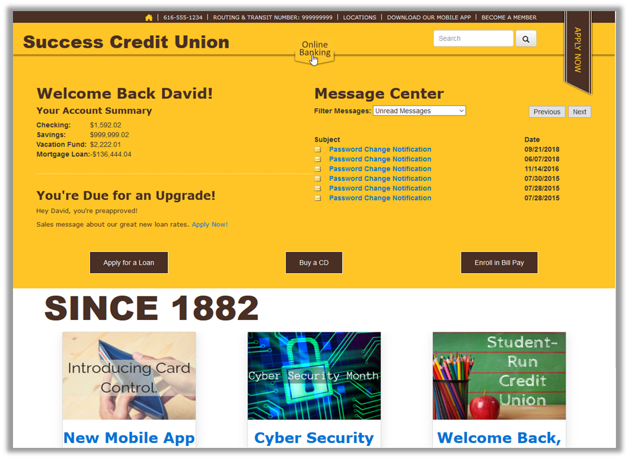.

Concept – Partial Authentication – First Visit
Showing first visit, or unauthenticated visit to a website. Once authenticated a cookie is set on the browser for future visits.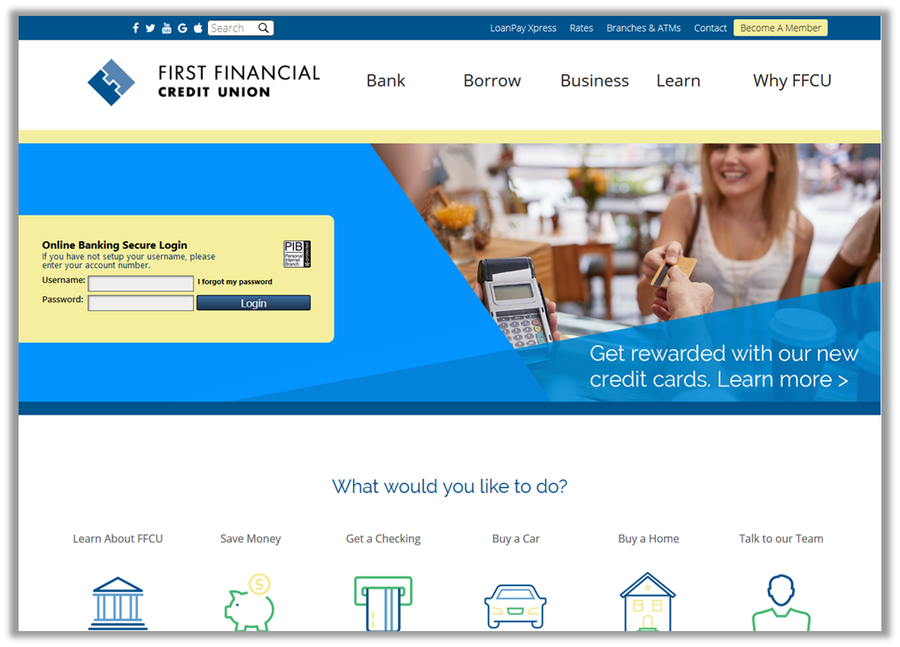.

Concept – Partial Authentication – Welcome back
Showing a return visit. Member does not need to reauthenticate to view quick account reference. 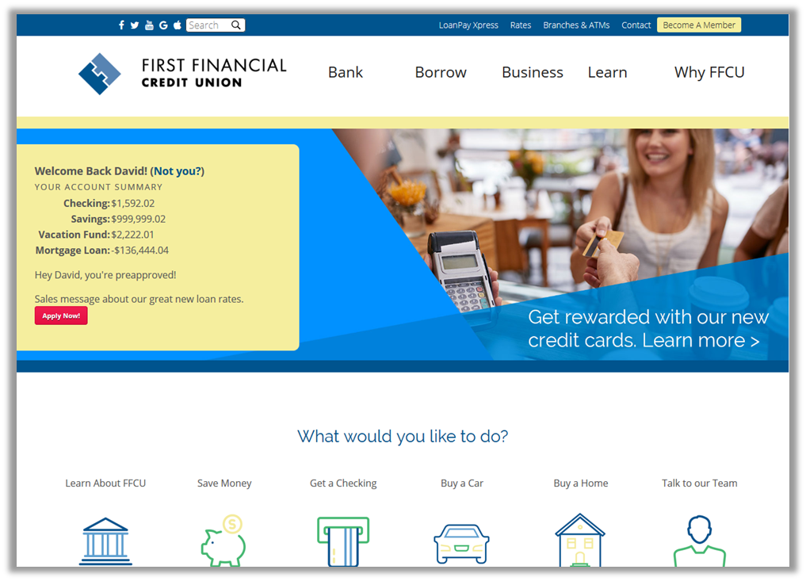…
.

Concept – Partial Authentication – First Visit
Concept for a partial authentication scheme, where members are shown basic information but must reauthenticate to perform any transactional actions. On first visit, or if partial authentication is reset, the member must log in to online banking.
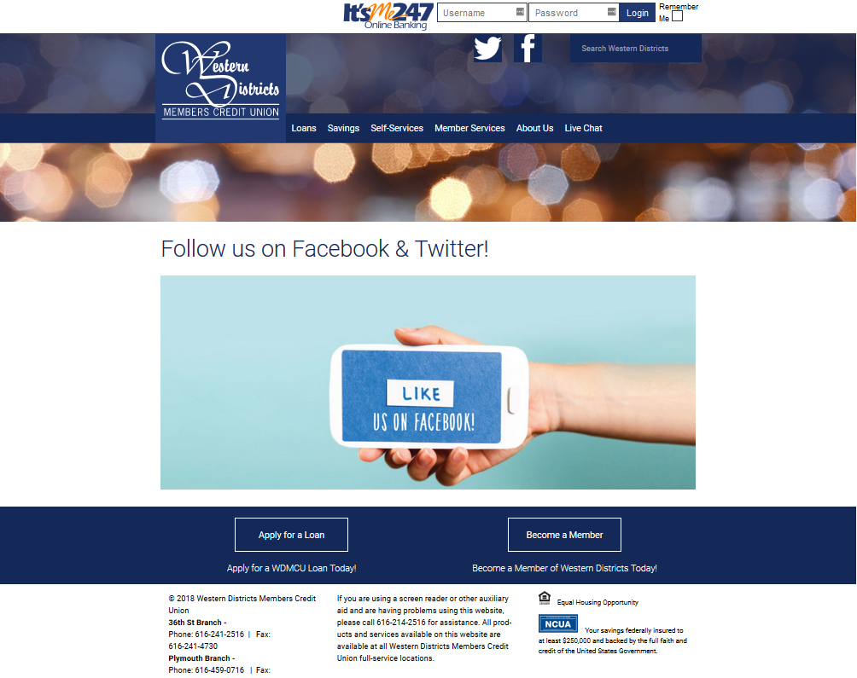

Concept – Partial Authentication – Returning Visit
Concept for a partial authentication scheme, where members are shown basic information but must reauthenticate to perform any transactional actions. On return visit, basic account details are shown. Member must log in to perform any transactions.
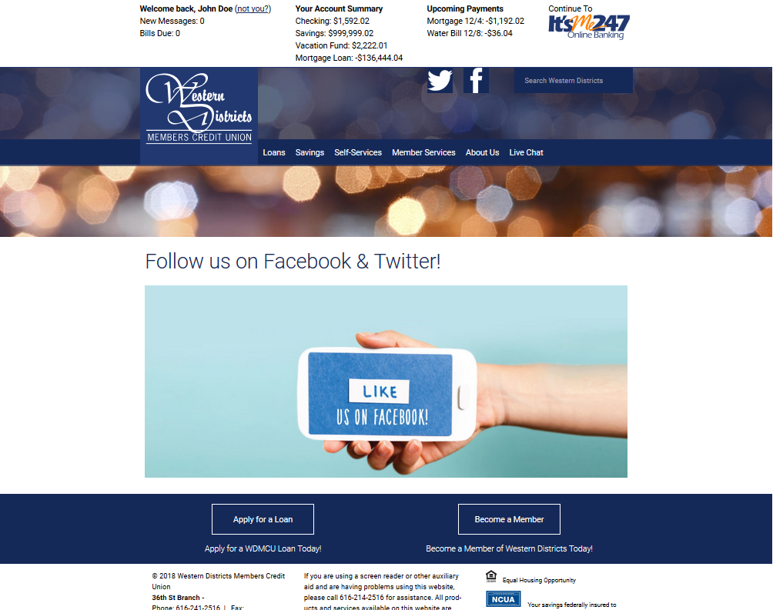

Concept – Partial Authentication – Log In
Concept for a partial authentication scheme, where members are shown basic information but must reauthenticate to perform any transactional actions. Log in to perform transactional online banking.
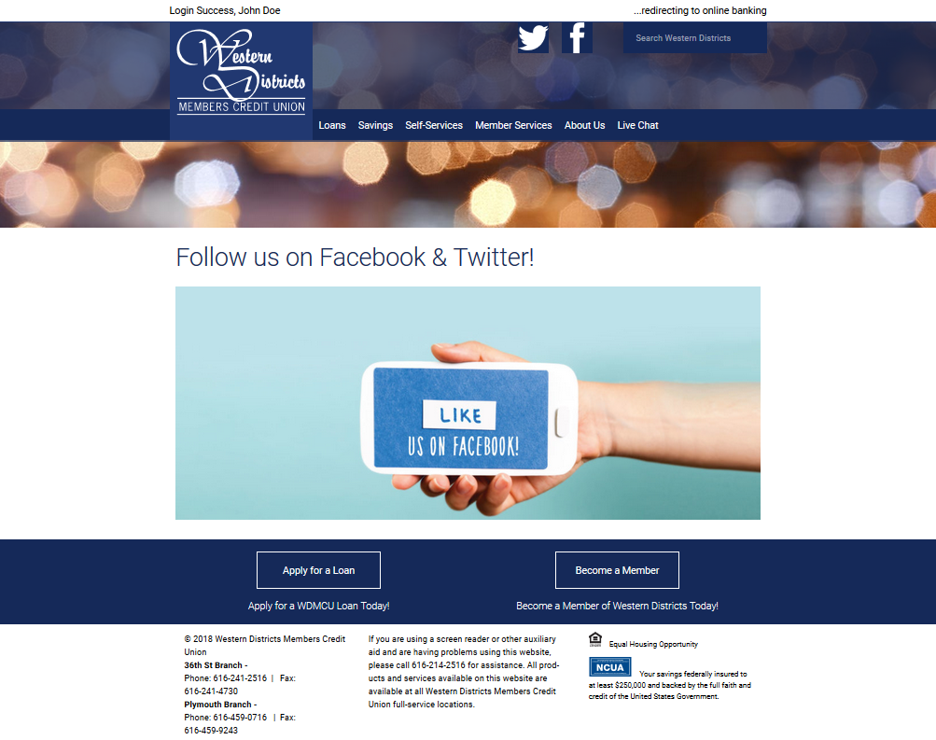

Concept – Partial Login – Dark Panels
Showing all three partial login panels - stacked, but with a matching color scheme.
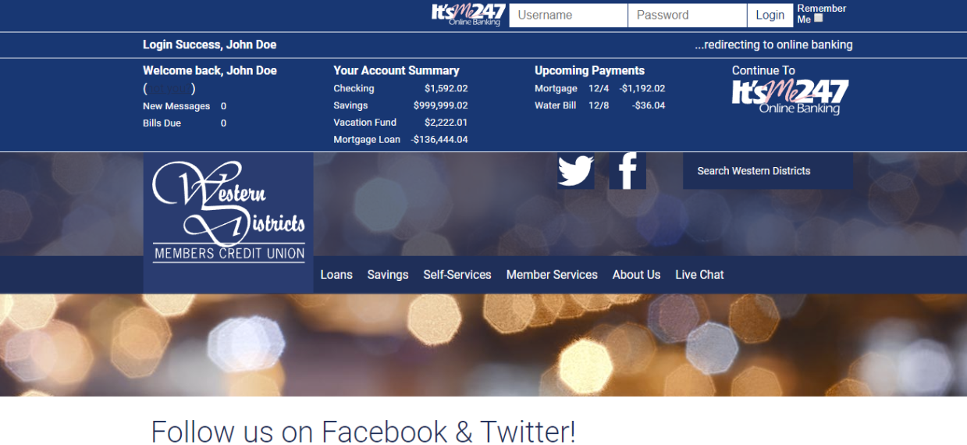

Appendix - Optics Events – It’s Me 247 Desktop
Optics statistics for It’s Me 247 Online Banking Desktop version from 4/1/2018 to 8/3/2018. Aggregators have been removed.
Activity | Count | Activity Percent | Without Login/Out | also without x details | per day | Comments
Viewed Transaction Details | 18,028,152 | 30.8753% | 57.1451% |  | 144,225.22
Logged In | 16,842,667 | 28.8451% |  |  | 134,741.34
Logged Out | 9,999,446 | 17.1252% |  |  | 79,995.57
Submitted A Transfer | 3,119,536 | 5.3426% | 9.8882% | 23.0737% | 24,956.29
Visited Bill Pay | 2,232,650 | 3.8237% | 7.0770% | 16.5138% | 17,861.20
Viewed A Check Image | 1,826,336 | 3.1278% | 5.7891% | 13.5085% | 14,610.69
Viewed Credit Card Account Information | 1,339,161 | 2.2935% | 4.2448% | 9.9051% | 10,713.29
Viewed Loan Account Information | 1,118,784 | 1.9160% | 3.5463% | 8.2751% | 8,950.27
Downloaded Transaction Details | 957,619 | 1.6400% | 3.0354% | 7.0831% | 7,660.95
Jumped To An Account | 665,330 | 1.1395% | 2.1089% | 4.9211% | 5,322.64
Paid A Bill | 656,600 | 1.1245% | 2.0813% | 4.8566% | 5,252.80
Viewed eStatements | 411,764 | 0.7052% | 1.3052% | 3.0456% | 3,294.11
Forgot Password | 160,902 | 0.2756% | 0.5100% | 1.1901% | 1,287.22
Viewed The Newsletter | 147,540 | 0.2527% | 0.4677% | 1.0913% | 1,180.32
Clicked On A Smart Message | 143,436 | 0.2457% | 0.4547% | 1.0609% | 1,147.49
Viewed Tiered Services Point Summary | 81,211 | 0.1391% | 0.2574% | 0.6007% | 649.69
Viewed Credit Score | 73,547 | 0.1260% | 0.2331% | 0.5440% | 588.38
Viewed Loan Rate Board | 69,807 | 0.1196% | 0.2213% | 0.5163% | 558.46
Viewed Certificate Account Information | 52,970 | 0.0907% | 0.1679% | 0.3918% | 423.76
Viewed Dividend/Interest Summary | 49,367 | 0.0845% | 0.1565% | 0.3651% | 394.94
Scheduled An AFT | 45,438 | 0.0778% | 0.1440% | 0.3361% | 363.50
Clicked A Customized Launch Point Link | 38,187 | 0.0654% | 0.1210% | 0.2825% | 305.50
Viewed Shares Rate Board | 36,182 | 0.0620% | 0.1147% | 0.2676% | 289.46
Submitted An A2A Transfer | 33,450 | 0.0573% | 0.1060% | 0.2474% | 267.60
Viewed New Loan Details | 29,164 | 0.0499% | 0.0924% | 0.2157% | 233.31
Viewed Mobile Web Banking Information | 27,726 | 0.0475% | 0.0879% | 0.2051% | 221.81 | <-- ????
Created A Payee | 26,676 | 0.0457% | 0.0846% | 0.1973% | 213.41
Changed Personal Information | 23,497 | 0.0402% | 0.0745% | 0.1738% | 187.98
Changed Security Questions | 22,268 | 0.0381% | 0.0706% | 0.1647% | 178.14
Viewed Certificate Rate Board | 19,285 | 0.0330% | 0.0611% | 0.1426% | 154.28
Viewed MoneyDesktop | 18,592 | 0.0318% | 0.0589% | 0.1375% | 148.74
Viewed New Share Details | 18,218 | 0.0312% | 0.0577% | 0.1347% | 145.74
Went To PIB | 12,283 | 0.0210% | 0.0389% | 0.0909% | 98.26
Enrolled In Bill Pay | 11,834 | 0.0203% | 0.0375% | 0.0875% | 94.67
Printed Loan Coupons | 10,878 | 0.0186% | 0.0345% | 0.0805% | 87.02
Sent A P2P | 8,929 | 0.0153% | 0.0283% | 0.0660% | 71.43
Viewed My Virtual StrongBox | 7,795 | 0.0133% | 0.0247% | 0.0577% | 62.36
Used A Skip-A-Pay Program | 6,640 | 0.0114% | 0.0210% | 0.0491% | 53.12
Viewed New Certificate Details | 3,875 | 0.0066% | 0.0123% | 0.0287% | 31.00
Viewed Investment Account Information | 3,710 | 0.0064% | 0.0118% | 0.0274% | 29.68
Created An ACH Distribution | 3,314 | 0.0057% | 0.0105% | 0.0245% | 26.51
Scheduled An A2A AFT | 1,893 | 0.0032% | 0.0060% | 0.0140% | 15.14
Changed Contact Preferences | 1,633 | 0.0028% | 0.0052% | 0.0121% | 13.06
Added A Check Stop Payment | 932 | 0.0016% | 0.0030% | 0.0069% | 7.46
Logged In via API | 546 | 0.0009% | 0.0017% | 0.0040% | 4.37 | <----- Members coming over from MAP/MOP
Created A Promise Deposit | 265 | 0.0005% | 0.0008% | 0.0020% | 2.12
Scheduled A CFT | 97 | 0.0002% | 0.0003% | 0.0007% | 0.78 | Check Fund Transfer - mail a check to a specified address

Appendix - Optics Events – It’s Me 247 Mobile
Optics statistics for It’s Me 247 Online Banking Mobile Web from 4/1/2018 to 8/3/2018. Aggregators have been removed.
Activity | Count | Activity Percent | Without Login/Out | also without x details | per day | Comments
Viewed Transaction Details | 41,573,539 | 48.6700% | 84.2623% |  | 332,588.31
Logged In | 15,999,404 | 18.7304% |  |  | 127,995.23
Logged In via API | 12,920,956 | 15.1265% |  |  | 103,367.65 | <-- Mobile App Users
Logged Out | 7,160,664 | 8.3830% |  |  | 57,285.31
Submitted A Transfer | 3,955,594 | 4.6308% | 8.0173% | 50.9432% | 31,644.75
Viewed A Check Image | 901,859 | 1.0558% | 1.8279% | 11.6148% | 7,214.87
Visited Bill Pay | 869,803 | 1.0183% | 1.7629% | 11.2020% | 6,958.42
Viewed Loan Account Information | 790,901 | 0.9259% | 1.6030% | 10.1858% | 6,327.21
Jumped To An Account | 392,652 | 0.4597% | 0.7958% | 5.0569% | 3,141.22
Viewed eStatements | 207,932 | 0.2434% | 0.4214% | 2.6779% | 1,663.46
Forgot Password | 163,298 | 0.1912% | 0.3310% | 2.1031% | 1,306.38
Paid A Bill | 141,294 | 0.1654% | 0.2864% | 1.8197% | 1,130.35
Viewed Dividend/Interest Summary | 133,789 | 0.1566% | 0.2712% | 1.7230% | 1,070.31
Viewed Shares Rate Board | 33,966 | 0.0398% | 0.0688% | 0.4374% | 271.73
Viewed New Share Details | 28,535 | 0.0334% | 0.0578% | 0.3675% | 228.28
Submitted An A2A Transfer | 21,689 | 0.0254% | 0.0440% | 0.2793% | 173.51
Changed Personal Information | 15,829 | 0.0185% | 0.0321% | 0.2039% | 126.63
Viewed Certificate Account Information | 15,255 | 0.0179% | 0.0309% | 0.1965% | 122.04
Viewed Loan Rate Board | 13,684 | 0.0160% | 0.0277% | 0.1762% | 109.47
Scheduled An AFT | 12,540 | 0.0147% | 0.0254% | 0.1615% | 100.32
Viewed Certificate Rate Board | 11,916 | 0.0140% | 0.0242% | 0.1535% | 95.33
Viewed New Loan Details | 9,618 | 0.0113% | 0.0195% | 0.1239% | 76.94
Sent A P2P | 9,078 | 0.0106% | 0.0184% | 0.1169% | 72.62
Viewed New Certificate Details | 8,735 | 0.0102% | 0.0177% | 0.1125% | 69.88
Changed Security Questions | 8,426 | 0.0099% | 0.0171% | 0.1085% | 67.41
Used A Skip-A-Pay Program | 5,792 | 0.0068% | 0.0117% | 0.0746% | 46.34
Created A Payee | 5,575 | 0.0065% | 0.0113% | 0.0718% | 44.60
Enrolled In Bill Pay | 3,973 | 0.0047% | 0.0081% | 0.0512% | 31.78
Changed Contact Preferences | 1,669 | 0.0020% | 0.0034% | 0.0215% | 13.35
Scheduled An A2A AFT | 891 | 0.0010% | 0.0018% | 0.0115% | 7.13
Added A Check Stop Payment | 423 | 0.0005% | 0.0009% | 0.0054% | 3.38

Appendix - Current It’s Me 247 Navigation
For reference
1.
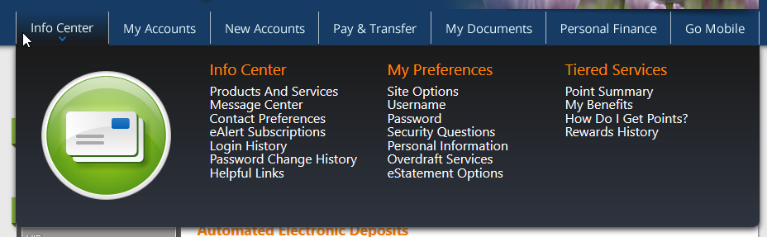
2.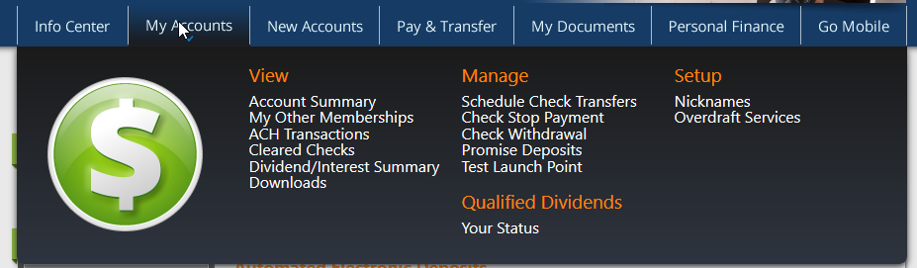
3.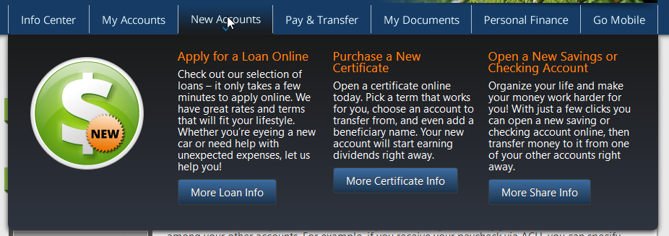
4.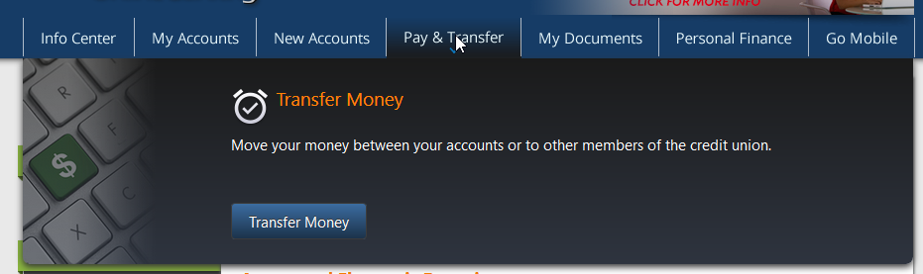
5.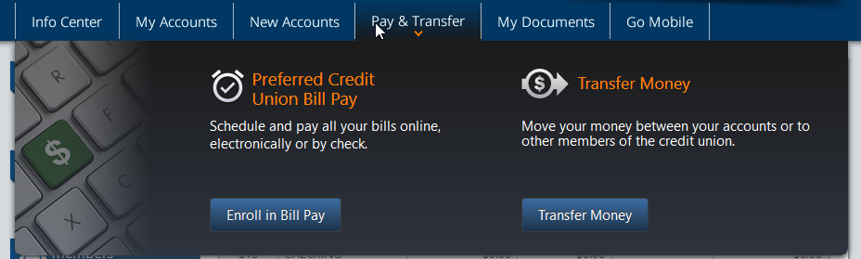
6.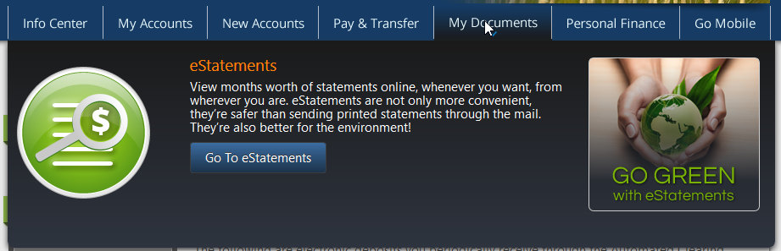
7.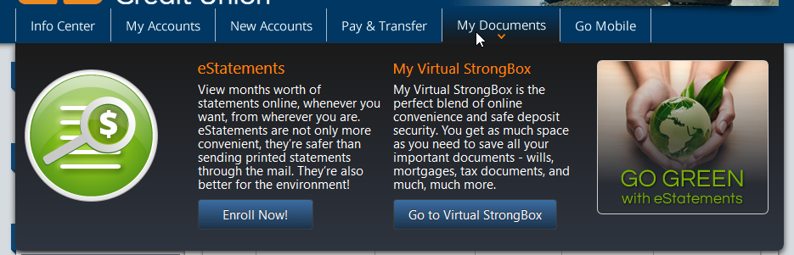
8.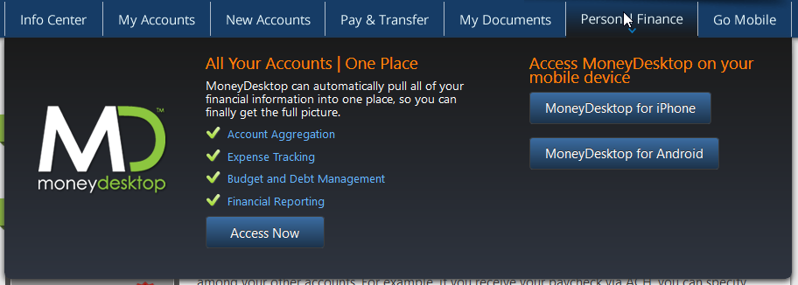

Appendix - Additional Reading

- Technology and Real-Time Data Give Marketers the Personalization ‘Golden Ticket’
  - https://thefinancialbrand.com/74183/technology-real-time-data-personalization-banking/
- Personalized Experiences Are The Only Way Banking Brands Can Differentiate
  - https://thefinancialbrand.com/75689/banking-marketing-personalization-ai-targeting-trends/
- Personalization: Moving From Optional to Necessity in Banking
  - https://thefinancialbrand.com/75321/digital-banking-personalization-strategy/
- Power of Personalization in Banking 2018
  - https://www.digitalbankingreport.com/trends/power-of-personalization-in-banking-2018/?2018-september-s
  - Digital Banking Report – August 2018
- Form Design Patterns
  - https://www.smashingmagazine.com/2018/10/form-design-patterns-release/

